Akshaya .K 240701031

Experiment No. 2: Setting up a Zoho Creator account and exploring the platform architecture and interface

Aim
To configure and examine the Zoho Creator environment by developing a Student Attendance Management application, creating data-entry forms and reports, preparing a dashboard, and understanding the purpose of the Develop, Deploy and Manage sections.

Setting up Zoho Creator
A Zoho Creator application named Student Attendance Management was planned to maintain student details, class information, attendance records and attendance summaries in one application.
The application was organized using the following forms:
  - Student Profile – Stores student ID, name, department, year, section and contact details.
  - Class Details – Maintains class code, subject name, faculty name, room and timetable information.
  - Attendance Entry – Records the attendance status of students for a selected class, subject and date.
  - Faculty Details – Stores faculty ID, faculty name, department, designation and assigned subjects.
  - Leave Request – Records student leave applications with date, reason and approval status.
  - Attendance Review – Tracks attendance summaries and identifies students who require attention.
Sample Application: Student Attendance Management
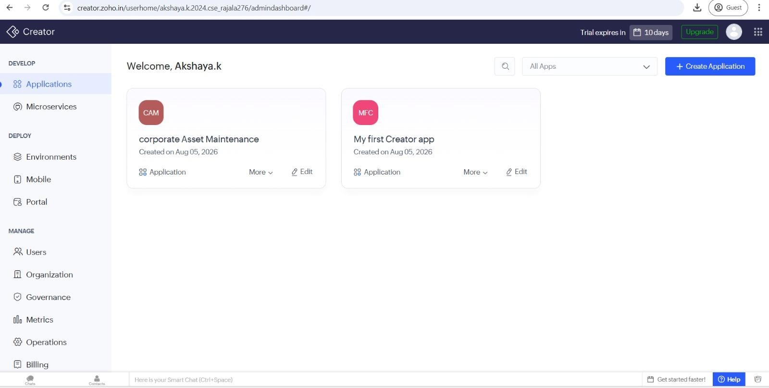

Creating Form
A form in Zoho Creator is used to collect information in a structured manner. Each field represents a particular piece of information, and submitted entries are stored as application records.
For this application, the Student Profile form can be used to collect student information such as student ID, student name, department, year, section, phone number and email address.

Explanation
The form divides student information into separate fields, which keeps records clear and consistent. After a user submits the form, the entry is stored in Zoho Creator and can be used in reports, dashboards and workflows.
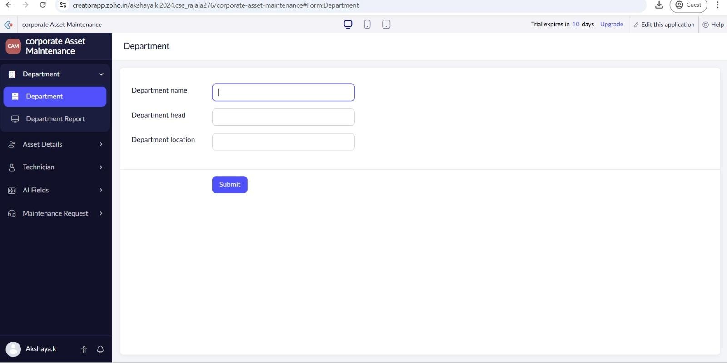

Creating Report
A report displays the records collected through a form in an organized view. It helps users search, sort and review information without opening every individual form entry.
The Attendance Report can be created from the Attendance Entry form. It may display student ID, student name, date, subject, class, attendance status and remarks.
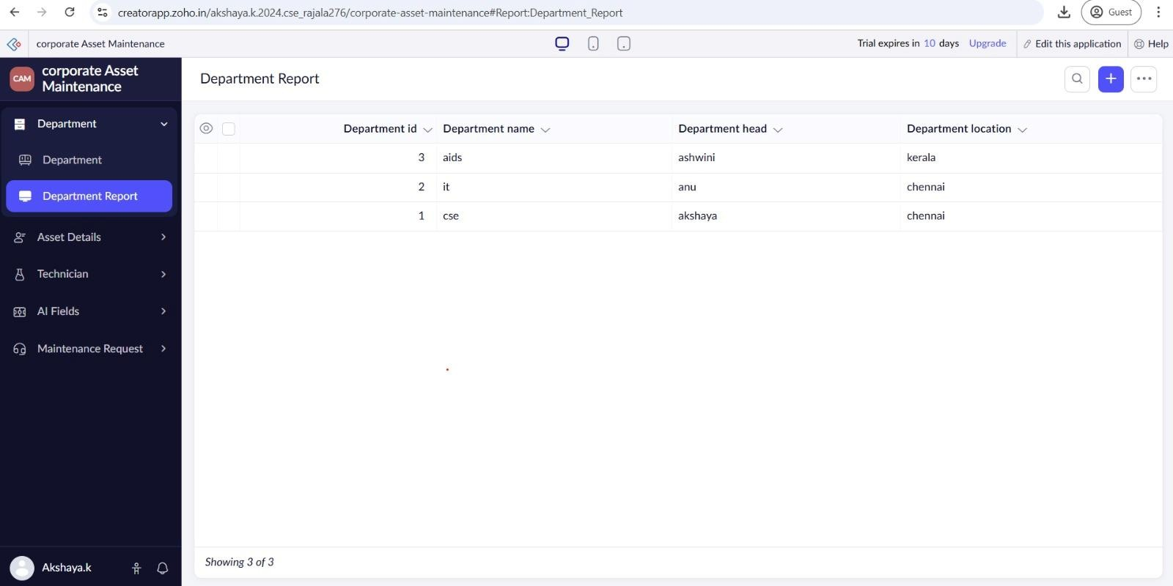

Explanation
The report brings attendance records together in a single searchable view. Faculty members can quickly check daily attendance, identify absentees and review records for a particular subject or date.

Creating Dashboard
A dashboard provides a compact visual summary of important application information. It allows users to understand attendance activity quickly by displaying key totals and summaries.
The Student Attendance Dashboard can display:
- Total Students
- Classes Conducted
- Students Present Today
- Students Absent Today
- Students with Low Attendance
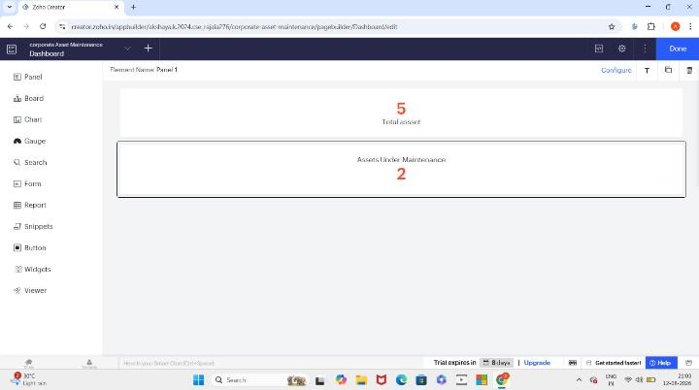

Explanation
The dashboard gives faculty and administrators a quick overview of attendance performance. Its values can change automatically when new attendance records are added or existing records are updated.

Exploring the Platform Architecture and Interface

Develop
  - The Develop area is used to create and customize the components of a Zoho Creator application.
  - It supports the creation of forms, reports, pages, workflows and dashboards.
  - Deluge scripting can be used to add validations, calculations, automation and application logic.

Deploy
  - The Deploy area is used to make the completed application available to its intended users.
  - The application can be accessed through supported web and mobile experiences.
  - User access and permissions can be configured according to different roles.

Manage
  - The Manage area supports administration and maintenance of the application after it is created.
  - It provides controls for users, permissions, data, application settings and integrations.
  - Administrators can monitor the application configuration and update it when requirements change.

Result
Thus, the Student Attendance Management application was configured and explored successfully in Zoho Creator. The experiment demonstrated the creation of forms and reports, the use of a dashboard for attendance summaries, and the purpose of the Develop, Deploy and Manage sections of the platform.
Conclusion: Zoho Creator provides an integrated environment for collecting data, presenting records, monitoring application information and managing access to an application.

